Taiga Testing Workflow
- Develop your environment per the instructions in the README.md file here
  - It is highly recommended to run the following tests while developing your environments

# navigate to the root directory of the taiga repository and start a virtual environment
uv python install
uv venv
source .venv/bin/activate
uv pip install ".[dev]"

# Tests to run
# metadata validation
uv run pytest tests/test_metadata_schema.py --problems-metadata-path=/path/to/your/problems-metadata.json

# Integration tests
# first build the docker image
docker build -t your-image-name -f Dockerfile .
uv run pytest tests/test_integration.py --problems-metadata-path=/path/to/your/problems-metadata.json

# full environment validation
uv run pytest -m validate_env --problems-metadata-path=/path/to/your/problems-metadata.json

- Make sure you can access https://taiga.ant.dev/jobs/
  - If you cannot, please reach out to your point of contact at Anthropic for assistance
- Build and push your docker image with a version number to your artifact registry
- Click into https://taiga.ant.dev/jobs/ and at the bottom right corner, click on “Create Job.”
- Fill in the fields below
  - Job Name: whatever you wish
  - Attempts per problem: keep this at 1 for initial testing, then can move up to 10
  - Select your model of choice
    - Sonnet 3.7: for initial iteration
    - Sonnet 4: For more thorough testing
    - Opus 4: For final assessments on whether the difficulty of the env is well-calibrated
  - Upload your problems metadata file
  - 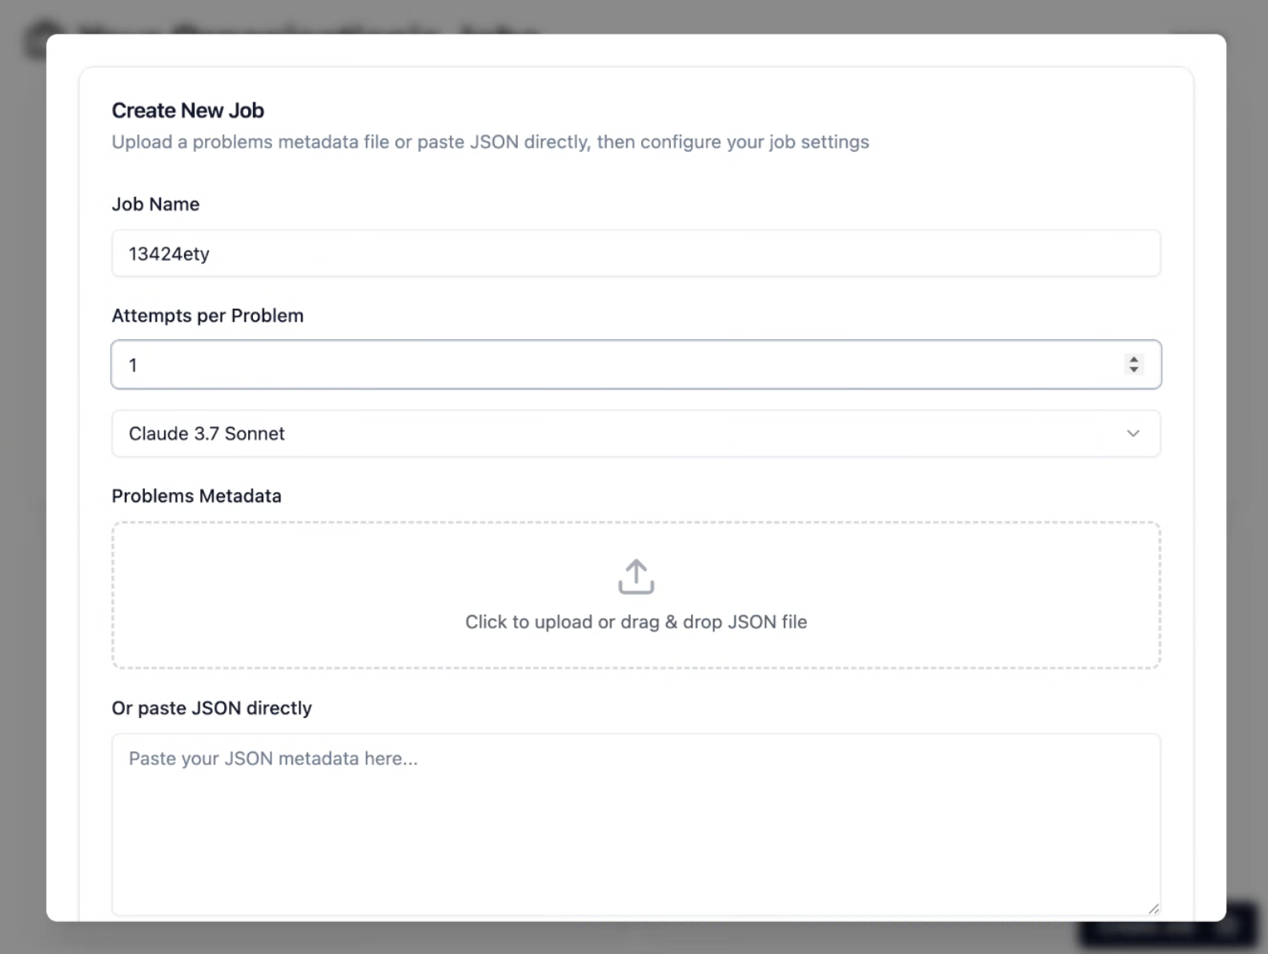
- A tile will be created for the job. Let it run. When you click into the tile, you will see a screen like this:
  - 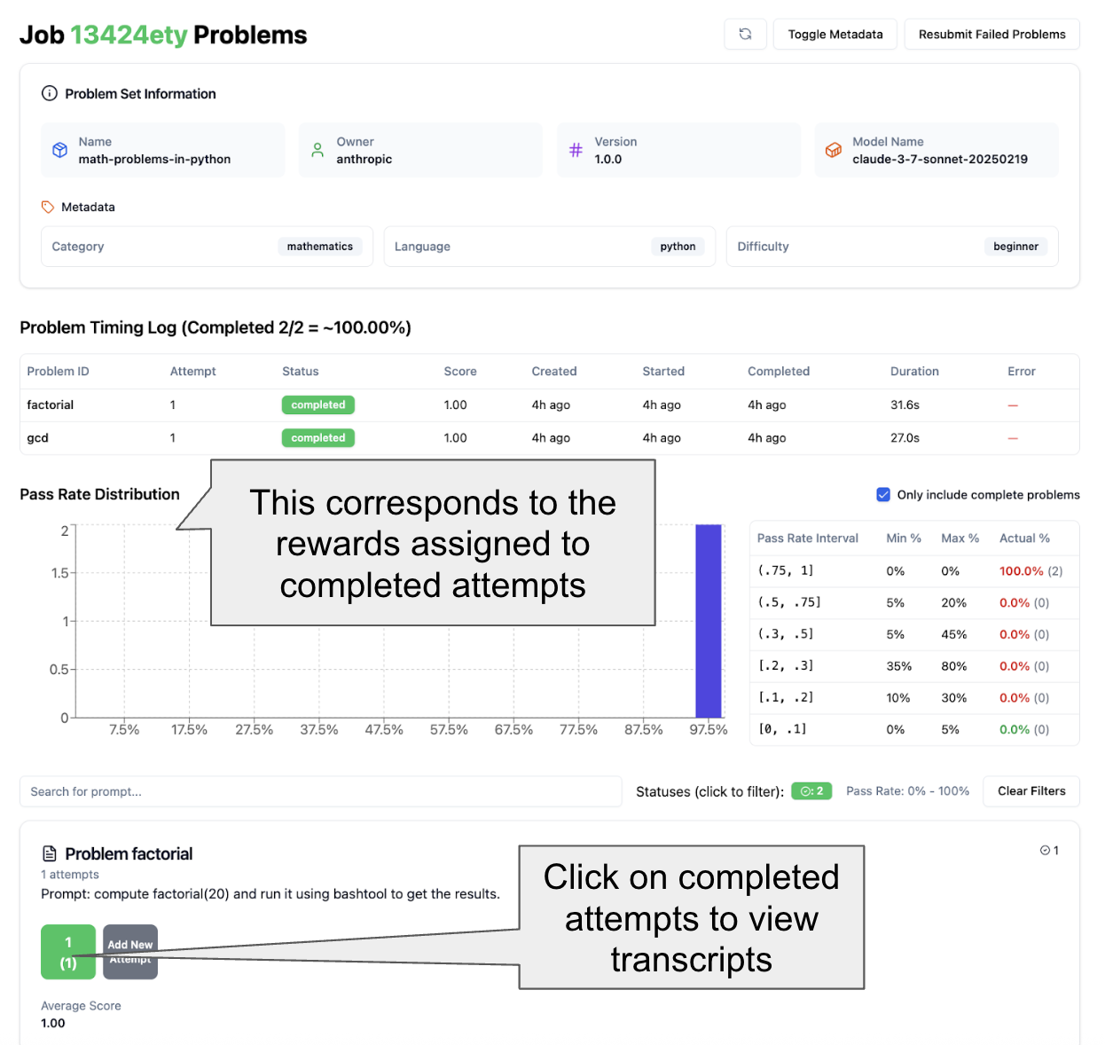
  - You can click into any completed attempts to view the transcript). Example screenshot below
  - 

